**Project Triumph**

Developed By:

Renegadeware

Version 1.0.0

# 

# Table of Contents

Contents

Table of Contents 1

Game Overview 4

Target Learning Objective (LO) 4

Demographics - Target Audience 4

Genre / Theme / Setting 4

Core Gameplay Summary 4

Look and Feel 5

Target Platform(s) 8

Game Flow 8

Part 1 – Light Energy 8

L.O. Concept(s) Covered 8

Summary 8

Mechanics 8

Losing Gameplay / Incorrect Concept Understanding 9

Mockups 9

Part 2 – Light, Sound Energy 10

L.O. Concept(s) Covered 10

Summary 10

Mechanics 10

Mockups 11

Part 3 –Physical, Sound Energy 11

L.O. Concept(s) Covered 12

Summary 12

Mechanics 12

Part 4 – Water, Physical, and Electric Energy 12

L.O. Concept(s) Covered 12

Summary 12

Mechanics 13

Part 5 – Heat (Fire/Steam), Water Energy 13

L.O. Concept(s) Covered 13

Summary 13

Mechanics 13

Part 6 – Heat (Fire/Steam), Water, Electric Energy 13

L.O. Concept(s) Covered 13

Summary 13

Mechanics 13

Part 7 –Wind Energy 14

L.O. Concept(s) Covered 14

Summary 14

Mechanics 14

Part 8 – Heat, Wind Energy 14

L.O. Concept(s) Covered 14

Summary 14

Mechanics 14

LO Concept Coverage 15

Academic Concepts 15

Legends of Learning Required Content Practices 15

Checklist Overview 15

Connection Between Gameplay and Learning 17

Role of Text in Learning 17

Characters - Diversity 17

Technical 18

Development Hardware/Software 18

Asset Summary 18

Music and Sounds 18

Art Style 20

Mechanical Artifacts 20

Spirits 21

Creatures 23

Schedule for Development + Delivery 24

Story / Narrative 24

Back Story 24

Plot Elements 25

# Game Overview

### Target Learning Objective (LO)

* [4-PS3.A-2: Forms of Energy Movement](https://drive.google.com/file/d/1maKdtaHiZjOe2KlV4SXdg3tUdEZfIr1l)

### Demographics - Target Audience

* Ages 8-11 (Grade School)

### Genre / Theme / Setting

* Puzzle Game – Players are tasked to power up an artifact. They do so by placing different types of energy into their respective chambers, while also manipulating the contraption to allow them to flow. Think in terms of rubrics cube, turning gears, and pipes.
* Energy Spirits and Mechanical Artifacts – The game will have a fantastical aesthetics, but still be grounded with real world logic.
* Whimsical Landscape – The world in the game appears bleak and colorless at first, but is then filled with colors and brightness as the mechanical artifact is powered up.

### Core Gameplay Summary

The game consists of three parts: Visual/Interactive Lesson, Mechanical Puzzle, Victory Marching Band. Most of the game happens during the mechanical puzzle. Whenever there’s a new type of energy introduced, the visual/interactive lesson are integrated into the puzzle. The victory phase will occur once the puzzle is solved, where the marching band grows in number as the game progress.

#### Visual/Interactive Lesson

The game will explain one or more energies, and how they interact in the environment. These lessons will occur during the mechanical puzzle gameplay. Dialog and illustration are presented to show the science behind the phenomenon.

#### Mechanical Puzzle

The goal of the game is to fully power up the mechanical artifact such that it emits sounds to form a melody. In most cases, the sounds are split into different parts and will only start to emit sound once they have a consistent flow of energy. After the artifact is fully powered up, it will descend into the lands to bring life.

The player is able to interact with various mechanics of the artifact, along with placing parts to allow the energy to flow.

In order to make the game more interesting, the way the player interacts with the artifact will vary based on how they are visualized. i.e., interacting with the mechanisms feel like you are actually manipulating it, rather than through an abstract UI.

The learning in the game happens when the player understands the interaction between energies as they are placed into the artifact. The player will understand how energies move, and generate power.

#### Victory Marching Band

Once the mechanical artifact is fully powered, it will descend into the land where it will arouse the creatures into action. These creatures will band together to follow the artifact, playing a tune along. This part of the game is simply a visual victory for the players to enjoy before they move on to the next lesson/puzzle.

### Look and Feel

* Energy Spirits – In order to draw in players to learn about the different types of energies, each energy is represented by a spirit with its own quirky personality.
* Mechanical Artifacts – The style will be that of Dr. Seuss/Moebius with all the gears and pipes. Much like the sketches found in the early 1600-1700’s, but more fantastical. They will also have a certain organic feel to them so that they do not appear too “boxy”.
* Landscape – Much like that of fairy tales in two contrasts: ominous and colorful. Shifting from ominous to colorful when the artifact emits its brilliance.

#### Moebius Art References

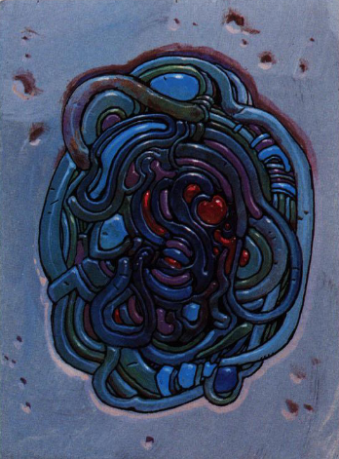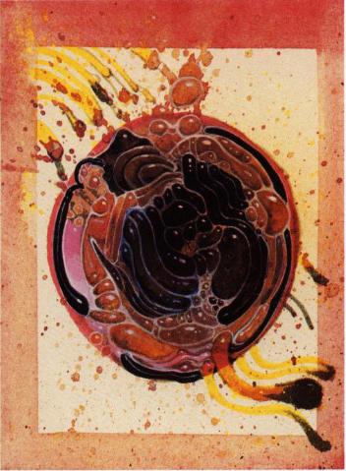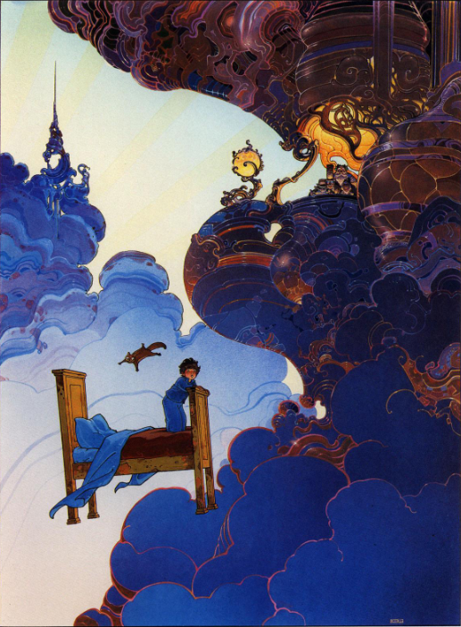

#### Dr. Seuss Art References

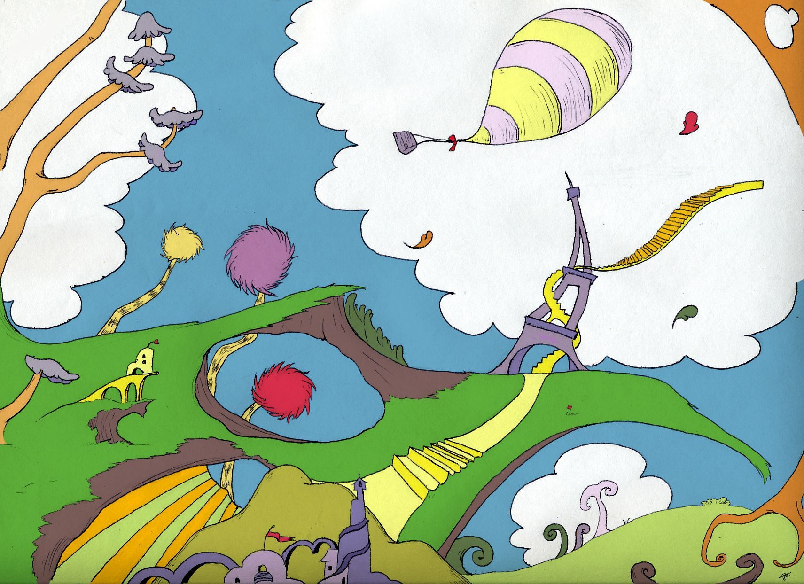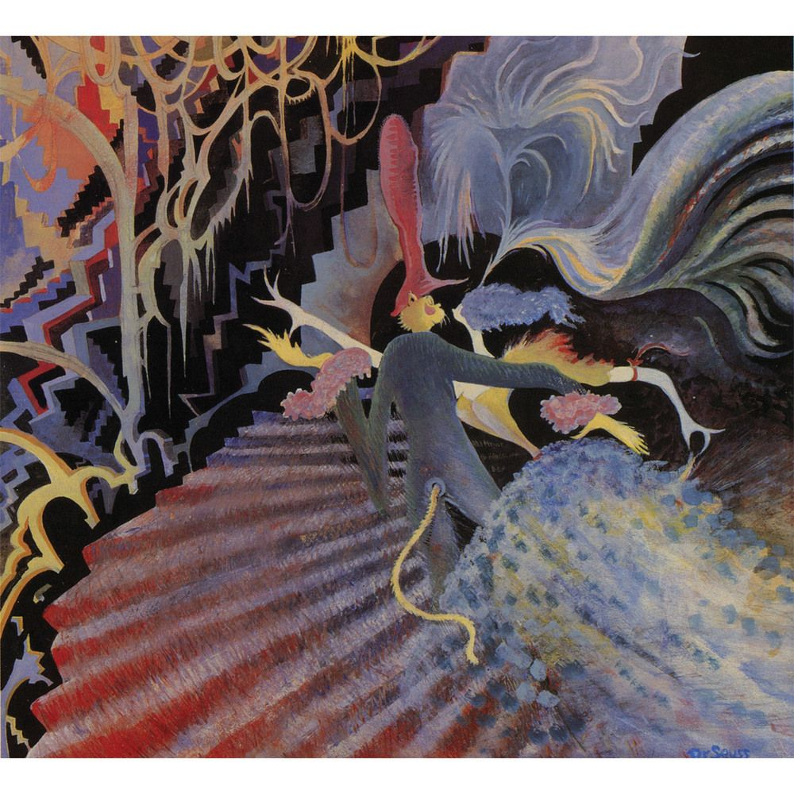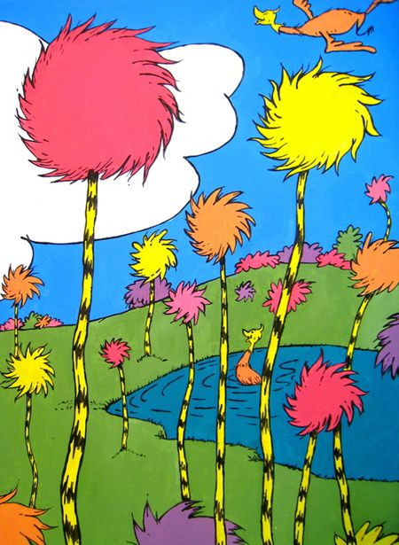

### Target Platform(s)

* WebGL with iPad support – Since the game is completely mouse driven, there should be no issue with playing the game in any platform that supports mouse or touch input.

# Game Flow

## Part 1 – Light Energy

### L.O. Concept(s) Covered

* Potential energy.
* Light transmits energy through electromagnetic waves.
* Transfer of energy from one form to another.

### Summary

This part of the game simply introduces the player to the concept of energy: from source (light), movement (light transmission), transform to another source (chemical to mechanical). The simple puzzle will also act as a tutorial for how to play the rest of the game.

* The scene will start in a dimly lit background with a creature asleep.
* A dialog pops up to discuss energy, and the potential of energy.
* A simple mechanical artifact is shown with a light energy.
* The tutorial for the gameplay is displayed for rotating the discs of the mechanical artifact to allow light to shine outwardly.
* Once the mechanical artifact is solved, more dialog is shown about how energy is moved from one source to another (in this case, light).
* Creature is awakened, background is lit up, creature proceeds to march forward. The game will move on to the next part.

### Mechanics

* Spirits: light
* The game will entirely be controlled by mouse (or touch screen)
* The player is tasked to rotate the two discs that will allow light to shine through. As the discs are properly rotated, it will lock in place. The game will guide the player on how to rotate the discs.
* Once all the discs are rotated properly, the game will proceed with further explanations, and finally the victory phase.

### Losing Gameplay / Incorrect Concept Understanding

* There is no lose condition for this game. However, the player must power the artifact in order to proceed.
* Depending on the complexity of the puzzle, a hint system will be implemented to show the player the solution. This can be after a duration, or after handling the artifact a certain amount of time. The hint system will either guide the player one step at a time, or all at once.
* Since this part of the game is a tutorial, the game will be guiding the player throughout the process.

### Mockups



|  |  |
| --- | --- |
| 1 – The lever allows for the disc to rotate. The player can click-and-move or drag to change rotation. This is an example of how interfaces within the artifact are mechanical, rather than through abstract UI. There will be other different ways for how players can interact with the mechanics throughout the game. | 2 – Light spirit. Light will flood through the discs as it is properly rotated. Eventually towards outside. In some artifacts, the player may be tasked to place spirits manually in different chambers. The spirit will emit their respective energy that simulates how it would work in physics. |

## Part 2 – Light, Sound Energy

### L.O. Concept(s) Covered

* Energy can be moved from place to place by light.
* Sound transmits energy through vibrations in materials.

### Summary

The game will explain how light energy can be moved from one place to another via reflectors. The way sound energy emitted by vibration is also explained here.

* Introduction of reflector to direct light energy.
* Explanation of how light can be transformed into sound through waves (In very surface level way without going into details, just that it is possible).
* Explanation of how sound can be emitted through vibrations.
* The main goal of the game is explained here where the player must power up the artifact to produce a series of sounds.
* Once the artifact is fully powered, it will descend into the land to awaken more creatures to follow the first one from the previous part. These creatures will play an instrument that follows the rhythm of the artifact, akin to a marching band.

### Mechanics

* Spirits: light
* Placeable parts: crystals for reflecting light.
* Rotate crystals that are in placed to change direction of reflection.
* Light must reach the light to sound energy converter to complete the artifact.

### Mockups



|  |  |
| --- | --- |
| 1 – Crystals that can be clicked/dragged, then placed within a hotspot of the artifact. Placeable pieces will generally appear here when needed. | 2 – Placeable hotspots. These will light up when the player picks up a placeable piece. This indicates where the player can only put a piece in. |
| 3 – Placed crystal. Once placed, they can be rotated or picked up again to place to a different hotspot. Just like the artifact mechanics, these interactions can be different depending on the context. | 4 – Light to sound converter. Player must power these up with light. They will start to activate once light touches the device. This will indicate progress to the player. Once all of these are activated, the puzzle is completed. Other artifacts are arranged the same manner, where sound instruments will become active once they are properly powered. |

## Part 3 –Physical, Sound Energy

### L.O. Concept(s) Covered

* Motion is the change in position of an object.
* Moving objects contain energy.
* Energy can be moved from place to place by moving objects.
* The energy transmitted by mechanical processes, light, sound, and electrical current can be used in many common applications.

### Summary

The game will have another explanation here about kinetic energy, as well as sound through vibration made from physical contact. Dialogs to explain these phenomena will activate as the player progresses through these parts.

* Introduction of physical object that exert kinetic energy (gravity, other moving objects)
* The game will remind the player that they must power up the artifact to produce a series of sounds. In this case, a sort of percussion.
* Just like from the previous part, the artifact will descend into the land to awaken more creatures. These will add more melody to the marching band.

### Mechanics

* Spirits – earth (metal ball).
* Spring powered plunger. Player uses this to move the kinetic spirit into action like a pinball.
* Levers to change direction/divert pathways for the spirit.
* Blocks to slide around to create paths.

## Part 4 – Water, Physical, and Electric Energy

### L.O. Concept(s) Covered

* The energy of motion is a kind of mechanical energy.
* Electrical current transmits energy through moving electric charges.
* Energy can be moved from place to place by electric currents.

### Summary

This part will further demonstrate kinetic energy with the water element. This will also show how energy can be stored through electrical charges generated from kinetic energy, and transferred via wires. This electrical energy can then power up another object to exert another form of energy (kinetic in this case).

### Mechanics

* Spirits: water, earth (gears), electric.
* Placeable parts: gears.
* Rotation of pipes, and chambers.

## Part 5 – Heat (Fire/Steam), Water Energy

### L.O. Concept(s) Covered

* Heat as a source of energy.

### Summary

This part will cover how heat is a kind of energy that can be used directly, or by transforming other materials to be a source of energy. The player will play around the use of heat to convert water into steam, and in turn will power up the artifact.

### Mechanics

* Spirits: fire, water, earth (gears).
* Placeable parts: gears.
* Rotation of platforms to rearrange pipes.

## Part 6 – Heat (Fire/Steam), Water, Electric Energy

### L.O. Concept(s) Covered

* Converting steam to electrical energy.

### Summary

This part further expands on heat as energy, as well as conversion of steam into electrical energy to be transferred across the artifact.

### Mechanics

* Spirits: fire, water, electric.
* Use of wires to redirect electrical charges.
* Rotation of platforms to rearrange pipes.

## Part 7 –Wind Energy

### L.O. Concept(s) Covered

* Energy can be moved from place to place by sound.

### Summary

This part will cover how wind is a kind of kinetic energy much like water. The player will also be dealing with transferring sound from one place to another.

### Mechanics

* Spirits: wind.
* Pipes and blocks.

## Part 8 – Heat, Wind Energy

### L.O. Concept(s) Covered

* Dealing with multiple types of energies.

### Summary

This is a continuation of wind mechanics, and having different source of energy.

### Mechanics

* Spirits: fire, wind.
* Placeable: fire spirits.
* Rotation of the artifact segment to arrange pathways for wind and fire.

# LO Concept Coverage

### Academic Concepts

|  |  |
| --- | --- |
| **Concept** | **Weight** |
| Electrical current transmits energy through moving electric charges. | Core |
| Motion is the change in position of an object. | Peripheral |
| Energy can be moved from place to place by sound. | Core |
| Sound transmits energy through vibrations in materials. | Core |
| Light transmits energy through electromagnetic waves. | Core |
| Energy can be moved from place to place by light. | Core |
| Energy can be moved from place to place by electric currents. | Core |
| Energy can be moved from place to place by moving objects. | Core |
| The energy transmitted by mechanical processes, light, sound, and electrical current can be used in many common applications. | Core |
| Moving objects contain energy. | Peripheral |
| The energy of motion is a kind of mechanical energy. | Peripheral |
| Waves transmit energy from one location to another, but they do not transmit matter. | Peripheral |
| The energy of motion is called kinetic energy. | Peripheral |

# Legends of Learning Required Content Practices

### Checklist Overview

[Google Doc Reference](https://docs.google.com/document/d/10yED8ZwFXOWjwvroqZxaHn1A6utMDncaFwmyc8dqc-g/edit?usp=sharing)

|  |  |
| --- | --- |
| **ITEM** | **COVERED** |
| Players should learn and be held accountable through gameplay-based problem solving and experience. Players should not be learning primarily through text-based instruction or assessment items. |  |
| Game does not include multiple choice assessment items. |  |
| All instruction is scientifically and mathematically correct. |  |
| Confirm that the game is linked to 2/3 or 5 main concepts of the total, whichever is greater. Confirm that the linked main concepts are correctly covered in the game. |  |
| All on-screen words spelled correctly and grammatically correct. |  |
| Vocabulary and reading level appropriate for the lowest grade level within the target audience and grade band. |  |
| Game does not include material that is inappropriate for school. This includes, but is not limited to: violence, firearms, bombs, knives, daggers, blood, gore, smoking, vaping, drug use, any mind-altering substances, alcohol, harm to human-looking characters, harm to animals, insinuating killing or death, ideally they’re always chased away rather than eliminated. If there is conflict with an enemy in game, they are chased away rather than eliminated or killed. (There can be death if it is in the context of the learning objective – ex. The food chain) If you have any questions about this policy and your game, please ask us. |  |
| Game avoids any stereotypic presentation of gender, race, region, or culture. |  |
| Characters are diverse in gender, race, culture, and ability. |  |
| Players cannot simply click through and complete the game without learning. Players should be prompted to re-learn and re-do portions of the game where they had poor results due to less understanding of the academic material. Avoid the word “FAIL” if the student incorrectly understands academic material. |  |
| Academic problems are not consistently repeated. Players are presented with different problems to solve. |  |
| Gameplay mechanic reinforces the academic material, rather than being completely separate from instruction. I.e, there is a focus on academic reasoning rather than concept / question repetition. |  |
| Gameplay is intuitive and a player in the target age range can navigate the game and beat it with enough effort. |  |
| Games should be fun and interesting, designed as non-educational games are designed, with design to encourage players to keep playing. |  |
| Game is between 5 and 25 minutes in duration. |  |
| All text must be large, clear and concise with font sizes that can be read on a small Chromebook screen. |  |

### Connection Between Gameplay and Learning

* The player will be powering artifacts using various types of energy. The way these energies interact will help players learn about their nature.
* Various puzzles in the game revolves around lining up pathways to transfer energy across the artifact. Players will understand how energy is transferred in many different ways.

### Role of Text in Learning

* Texts will be used to introduce the player to the world, as well as instructions.
* Each of the lesson will be accompanied with a brief scientific explanation of the energy and their functionality.
* To alleviate the use of texts, most of it will be in a form of a dialog speaking directly to the player. This allows for better engagement when learning the subject.

### Characters - Diversity

* Spirits – each spirit represents a form of energy. Their appearance and personality reflect this.
* Creatures – they resemble rams and ewes. They appear lost and forlorn until they hear the music, shaping each of them to their own personality.
* The ever-reassuring robot will be there to help teach the player about the various types of energies, and how they are applied in the world.

# Technical

### Development Hardware/Software

* All development will be done in Windows 10.
* iPad 6 for tablet testing.
* Browsers: Firefox, Edge, Chrome, and Safari (via iPad 6)
* Game Engine: Unity 2022.3+

### Asset Summary

* Since artifacts have organic, non-orthogonal look to them, scaling while saving project file size will be tricky. In this case, many of the visuals will make use of polygons.
* All other art in the game will use conventional 2D artwork.
* Music will be dynamically composed by the game as artifacts are solved. Hopefully this will have the effect of also reducing project file size.

### Music and Sounds

* Music
  + A rhythmic beat plays when artifacts are completed. There will be a rhythm for each level except the first one, a total of 7.
  + Each rhythm is added to the victory marching band as more creatures join the march. The instruments played by the band will match these beats.
  + All tracks for the marching band should be short (0:30), since this is only played as the puzzle is solved, and in the victory scene. The whole orchestra will be played in the end scene.
  + A soft ambient hymn is played in the background during the mechanical artifact. This needs to blend well, and not overpower with the rhythm that is played.
* Sound
  + Metallic gears grinding/turning – loop, 1-2 seconds.
  + Snappy leaver pull – ~1 second.
  + Mechanical switch - ~1 second.
  + Light emission – glittery, magical. 1-2 seconds
  + Light beam emission - think sci-fi droning beam appearing, 1-2 seconds.
  + Electrical emission – 1-2 seconds.
  + Fire emission – can be a snap, or when a stove heats up, ~1 second.
  + Water sizzle – water boiling, loop. 1-2 seconds.
  + Water flow – water filling up, loop. 1-2 seconds.
  + Hard rock contact – a thud noise. ~1 seconds.
  + Bell ding – quick small bell ring. ~1 second.
  + Wind – billowing wind, loop, 1-3 seconds.

# Art Style

### Mechanical Artifacts





Example artifacts #1 and #2

### Spirits





Various spirits as they appear in the game.

### Creatures



The marching band creatures.



Creatures move forth in a marching band.

# Schedule for Development + Delivery

* Projected coding time: 2 – 3 weeks. (Coding will also accommodate time for implementing art, sound/sfx, lessons, polish)
* Projected art/design time: 2 – 3 weeks.
* Projected lesson implementation time: 1 week. (These will most likely be part of the level design phase.
* Projected polish time (intro, ending, etc.): 2 – 3 weeks.

# Story / Narrative

### Back Story

* The world is plunged into darkness. Only through the power of the artifacts can it be restored to light, with the movement of music.

### Plot Elements

* As artifacts are assembled, the world lights up.
* For each artifact, more and more creatures gather to participate in the marching band.
* Ultimately the entire world comes back to life.